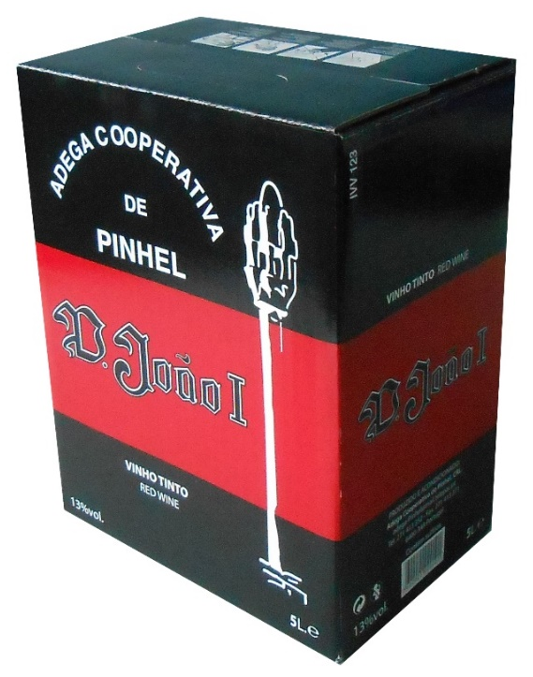 | DENOMINAÇÃO |  | METION
 | Vinho |  | Wine
 | CASTAS |  | GRAIPS VARIETEIS
 | 60% -Tinta Roriz – 30% - Touriga Francesa – 10% Touriga Nacional. |  | 60% -Tinta Roriz – 30% - Touriga Francesa – 10% Touriga
 | CARACTERÍSTICAS ORGANOLÉTICAS |  | ORGANOLYTIC CHARACTERISTICS
 | ESPÉCIE: Tinto  ASPETO: Límpido  COR: Rubi  Espuma: Branca |  | SPECIES: Red  ASPECT: Clear  COLOR: Ruby  Foam: White
 | ANÁLISES |  | ANALYSIS
 | Álcool (% vol.) –13.0 %  Acidez Volátil (gr. Ac.acetico/l) – Inferior ao limite legal  Acidez Total (gr. Ac.tartarico/l) – 5.0 gr/l.  pH – 3.51  Sulfuroso Total – Inferior ao limite legal |  | Alcohol (% vol.) -13.0%  Acidity Volatile (Ac Acceptable / l) - Less than the legal limit  Total Acidity (tartaric acid / l) - 5.0 gr / l.  pH = 3.51  Sulfurous Total - Less than legal limit
 | CONSUMO |  | SERVICE
 | Servir aproximadamente a 16ºC |  | Serve at approximately 16ºC
 | GASTRONOMIA |  | GASTRONOMY
 | Excelente acompanhamento para pratos carnes e peixes gordos e queijos |  | Excellent accompaniment to meat dishes and fish and cheeses
 | NOTA DO ENÓLOGO: Luís Ribeiro |  | NOTE FROM THE ENOLOGIAN: Luís Ribeiro
 | Vinho muito equilibrado de taninos e acidez, conferindo-lhe presença e frescura de boca. Final de boca correto. |  | Very balanced wine of tannins and acidity, giving it presence and freshness of mouth.
 | OBSERVAÇÕES |  | COMMENTS
 | Bag-in-Box: 3L, 5L, 10L, 15L |  | Bag-in-Box:3L, 5L, 10L, 15L

